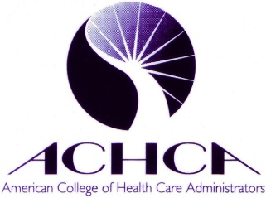
New Hampshire Chapter
of ACHCA

Goodbye Volume, Hello Value: Transitions from Fee-for-Service to Value-Based Payment Workshop

November 14, 2017

9am to 12:30pm

Centennial Inn, 96 Pleasant Street

Concord, NH 03301.

Please enclose a check for $30 if ACHCA member; $45 if non-member; Please make payable to: NH Chapter of ACHCA

Mail check to: Roxie Severance, 544 Jefferson Road, Whitefield, NH 03598 (attendees can bring check to workshop) but need to scan or email attendance form to: roxie@rsconsulting.services

Name:

Facility:

Mailing address

Email:

Yes, I will stay for NH Chapter Annual Meeting and Lunch
Sorry, I’m unable to stay for the NH Chapter Meeting, but am excited to attend the workshop.

